Pagination Findings: Firefox vs Chrome/Edge
1.Firefox is targeting correct frame for reload - OOTB
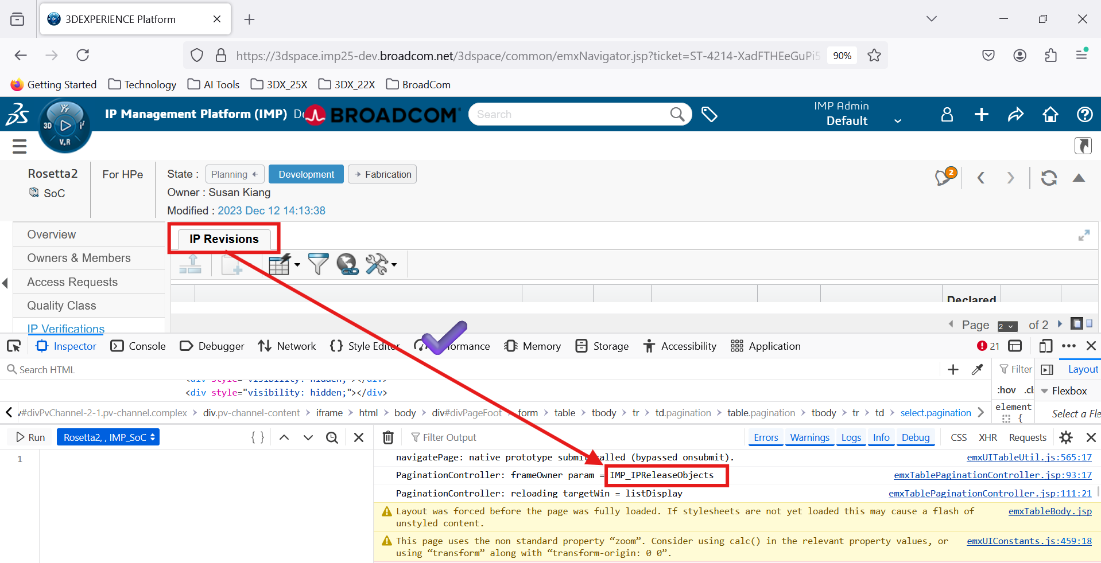

2.Chrome/Edge is targeting wrong frame for reload - OOTB
